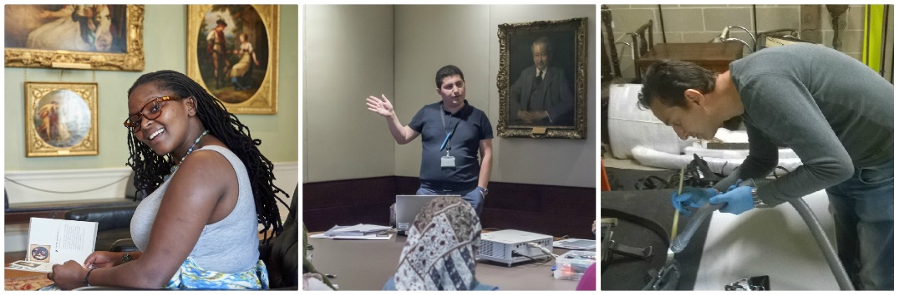
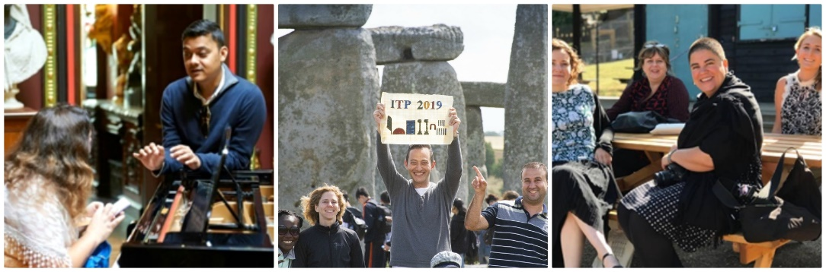

“I was pleased when I saw some changes in the programme that we had suggested to the Senior Fellow in 2017, and it feels good to be taken into consideration. This experience is revitalising and reassuring for one’s career and future projects”
Senior Fellow 2018

“I was very happy to be back and to take part in this amazing experience again as the first time it had helped me a lot to reshape my ideas regarding working as a museum professional.”
Senior Fellow 2019

International Training Programme
Summer Programme 2020: Senior Fellow Role
Applications open!

We are pleased to announce applications for 2020 are now open!
The role of Senior Fellow is taken on by a former ITP fellow to help facilitate the Summer Programme. Having participated on the Summer Programme previously you will provide fellows of 2020 with knowledge of the course, of London and our UK partner museums.

The role offers the opportunity to gain further training in the delivery and development of skills-sharing programmes, to reconnect with BM and UK partner colleagues and to make new connections across our global network.

You will be an invaluable member of the ITP team, helping with the logistics and development of the summer programme, offering ideas for our legacy and sustainability projects, and providing support to the ITP team and fellows during the summer. You will also take on the role of ‘guest editor of the ITP Newsletter 2021 helping develop the theme and content.

For more information and to apply read through and fill in the application form. If you have any more questions email itp@britishmuseum.org. Please submit your application by Friday 31st January 2020.

