**INTERNATIONAL TRAINING PROGRAMME**Annual Programme 2025: Senior Fellow role

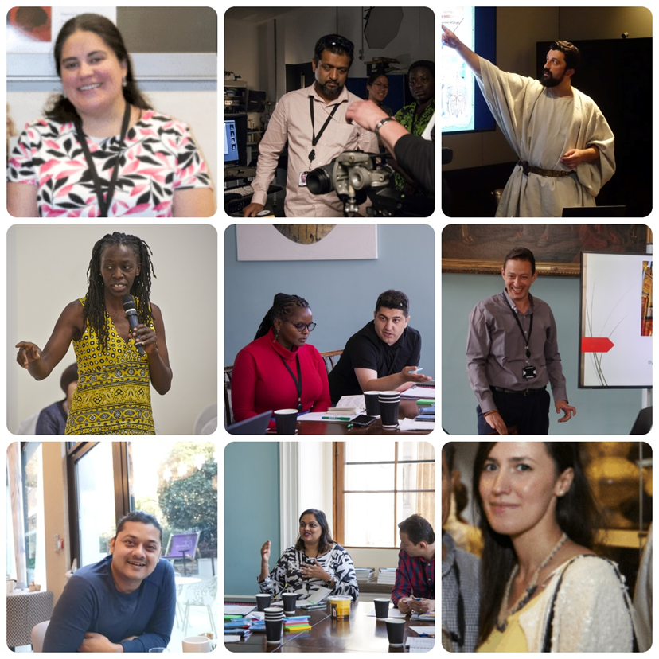

**We are pleased to announce applications for the 2025 Senior Fellow role are now open!**

The aim of the placement is for a former ITP Fellow to bring their invaluable experience of the Annual Programme, of London and our UK partner museums to next year’s participants.

Your dates – 22 June to 31 August 2025

Annual programme dates - 5 July to 17 August 2025

**We will offer you:**

* the chance to assist with developing ideas and strategies for our annual programme and legacy projects.
* experience of organising and delivering training programmes including: developing the flexibility needed to adapt to fellows’ needs and requests; working to immoveable deadlines; working with departments, contributors and partners.
* the chance to further expand your professional network by communicating with colleagues from around the world.
* time in the departments of your choice at the British Museum and a visit two or more UK partner museums, to re-connect with colleagues and develop new relationships.
* a personalised programme consisting of meetings with the ITP team to understand how the programme is funded, the course is developed and the logistics arranged, and the programme delivered evaluated and finally reported back to stakeholders. Subjects will include the importance of partnerships and social media.
* the opportunity for meetings outside of the British Museum to create new and exciting networks of colleagues around the UK.
* the necessary skills to cascade your knowledge and experience at your own institution.

**As part of the role we will ask you to:**

* prepare documents and contribute to the planning of the annual programme before you arrive in the UK.
* contribute to the delivery of ITP workshops during the annual programme.

*Themes include introduction to the annual programme, networking skills, national programmes & UK partner placement, and a variety of subject specialist sessions.*

* Deliver a presentation on your current role, projects and programmes and explain your role as Senior Fellow.
* Lead and a workshop for the cohort 2025 based around the concept of The Future of Museums.
* blog on a weekly basis to create a diary of your role, experiences and achievements and be part of the increasing on-line presence of the ITP.
* assist the ITP team with administrative, logistical and practical tasks throughout the programme, including weekend and evening events and supporting fellows whilst staying at London based accommodation alongside them. *The workload can be uneven, resulting in some busy and long days mixed with quieter days with more normal working hours.*
* reaffirm what is expected of fellows throughout the programme and assist with their pastoral care. To act as a bridge between the ITP team and fellows.
* help evaluate the programme both from a personal perspective and to feedback on comments from programme attendees and facilitators.
* write an article for the ITP annual report about your experience as a senior fellow.
* guest edit and help to develop the theme of the 2026 ITP newsletter.
* you will also be invited to join the new ITP Advisory Group made up of the ITP Senior Fellows who are bringing their skills, knowledge and lived experience of culture and heritage sectors around the world, to help shape the International Training Programme.

We hope that the successful candidate will join us from **22 June to 31 August 2025** for the **Annual Programme at the British Museum.**

We will cover the cost of flights, your UK travel, accommodation, subsistence and any visa related expenses. We will make all necessary arrangements for you.

2025 Annual Programme fellows will arrive on **5 July to 17 August** and the Senior fellow will stay on for a further 2 weeks to assist with the ITP evaluation and write a report.

**Before applying:**

* ensure that you are available for the dates above (although dates for your visit can be discussed).
* ensure that you have the permission of your institution and immediate line-management to take on the role.
* ensure that you are able to obtain a visa for this period.
* ensure that your passport is valid until at least **end February 2026** (6 months after the day of your departure from the UK).

**To apply:**

|  |  |
| --- | --- |
| Name:- |  |
| Job title:- |  |
| Institution:- |  |

**Please answer the following questions. Write up to 200 words to answer each question.**

**Present job description:-**

Please write a paragraph about your responsibilities and day-to-day work. This information will be used to create a biography for you.

|  |
| --- |
|  |

What is your understanding of the Senior Fellow role? What does the role mean to you?

What can you bring to the role? Please give details of any training courses or events you have organised before.

Have you been involved in any ITP legacy projects or ITP related projects before? If yes, please make a list below and explain what you took from each experience.

What digital experience do you have? For example, blogging, Facebook, twitter

What post-ITP experience do you have of international networking that might be useful to the participants during the annual programme?

How will you use what you learn on the programme upon your return home, and how will this benefit you and your institution?

When the 2025 ITP fellows return home you will spend two weeks working with the ITP team to write reports, evaluate the annual programme, meet with colleagues and visit institutions relevant to you. Think about your professional interests and write down:

Your areas of interest

The people you would like to meet while in London

Departments you would like to visit in the BM. You can explore the BM’s departments by visiting this page: <https://www.britishmuseum.org/our-work>

Institutions you would like to visit during your time in the UK

Please also state which UK partners you would like to visit and why. Please select from the list below.

*Glasgow Museums, Lincoln Museum, Manchester Art Gallery, Manchester Museum & The Whitworth Art Gallery, Norfolk Museums Service, Nottingham University Museum, Tyne & Wear Archives & Museums*

Submit your answers to the questions above **AND YOUR CV** by **Midday (GMT) on Friday 20 December** to [itp@britishmuseum.org](mailto:itp@britishmuseum.org)

For more information, please contact George Peckham at [gpeckham@britishmuseum.org](mailto:gpeckham@britishmuseum.org).